Amit Nijjar

A11489111

CSE 150

Assignment 4 Report

Problem 1 and 2 and 4 on paper

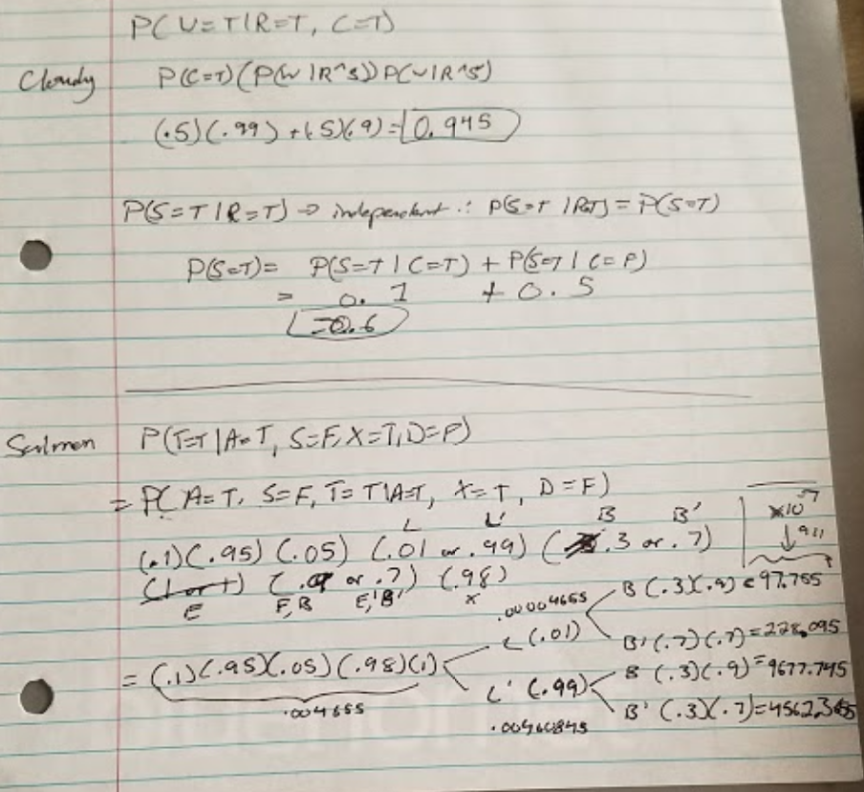

Algorithms

Rejection Sampling:

Rejection sampling is an approximate algorithm in a bayes network. You average the values of multiple iterations of the network and normalize it to get the probability. Using random numbers, I was able to create the multiple paths used to approximate the probability.

Likelihood sampling:

Like rejection sampling, likelihood sampling is another approximate algorithm in bayes network. I normalized the total sum of valued samples similarly to the end of rejection sampling.

Gibbs Sampling:

Gibbs sampling is based off of the markov blanket. I set a value based on the markov blanket of a node and then return the probability based off of the markov blanket values. Then I normalize the probability in the end.

Problem 3

Test 1(Rain = true, Cloudy = true)

rejection sampling: 0.895793131607

weighted sampling: 0.908168163363

gibbs sampling: 0.911533230665

Test 2 (Rain = true)

weighted sampling: 0.500176153606

rejection sampling: 0.500441082041

gibbs sampling: 0.180966952672

Test 3 (rain = true, cloudy = true, sprinkler = true, wetgrass = true)

weighted sampling: 1.0

rejection sampling: 0.940168510839

gibbs sampling: (0, 0)

Test 4 (sprinkler = true, wetgrass = true)

weighted sampling: 1.0

rejection sampling: 0.812122062294

gibbs sampling: 1.0

Test 5 (wetgrass = true)

weighted sampling: 1.0

rejection sampling: 1.0

gibbs sampling: 1.0

I found that 5 trials were needed to give an estimate close to the actual probability.

Test 1 (Asia = true, smoker = false, xray = true, dispnea = false)

rejection sampling: 0.0154255027442

weighted sampling: 0.263697526697

gibbs sampling: 0.839386787736

Test 2 (asia = true, smoker = false, bronchitis = true)

rejection sampling: 0.549948582877

weighted sampling: 0.807426148523

gibbs sampling: 0.79981799636

Test 3 (asia = true, smoker = true, tb_or_cancer = false, bronchitis = true)

rejection sampling: 0.00545867713872

weighted sampling: 0.0

gibbs sampling: 0.0

Test 4 (asia = true, smoker = false, xray = true, dispnea = false, bronchitis = true, tb = false)

rejection sampling: 0.390104653161

weighted sampling: 0.0

gibbs sampling: 0.0

Test 5 (asia = true, smoker = false, bronchitis = true)

rejection sampling: 0.0956084862684

weighted sampling: 0.105282105642

gibbs sampling: 0.980419608392

I did this project solo.